**Category**

Health & Fitness or Navigation

**Description**

Walkr is your ultimate companion for exploring urban environments on foot. Whether you're a casual stroller or a dedicated walker, Walkr helps you track your walks, discover new routes, and capture memories along the way. Walkr is perfect for urban explorers, fitness enthusiasts, and anyone who loves to walk. Download Walkr today and start your walking adventure!

**Keywords**

walking, urban exploration, fitness, GPS tracking, route planner, walking routes, location pins, walking app, health

☐ Screenshots (up to 5 per device)

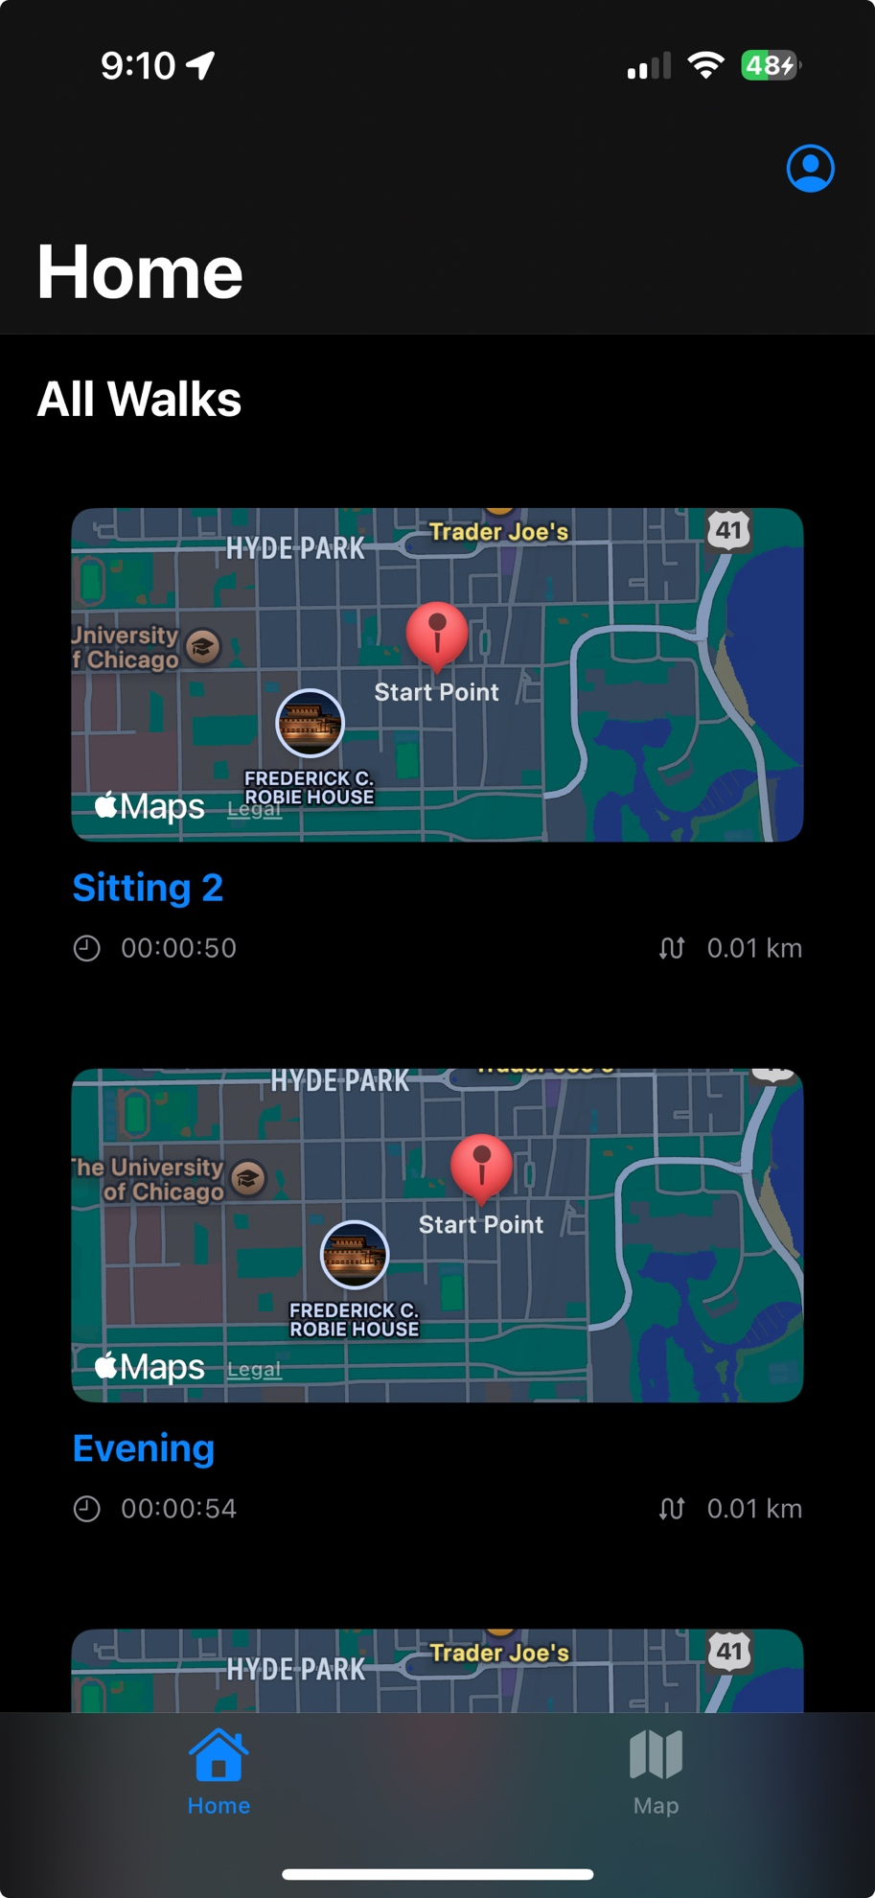

**Age Group**

17+